DATE …………………………………… STUDENT NO……………………………...…………..…

EXAMINATION CENTRE ……………………………………………..………...…………..…………..

THE SHIPPING AND FORWADING AGENTS’ ASSOCIATION OF ZIMBABWE

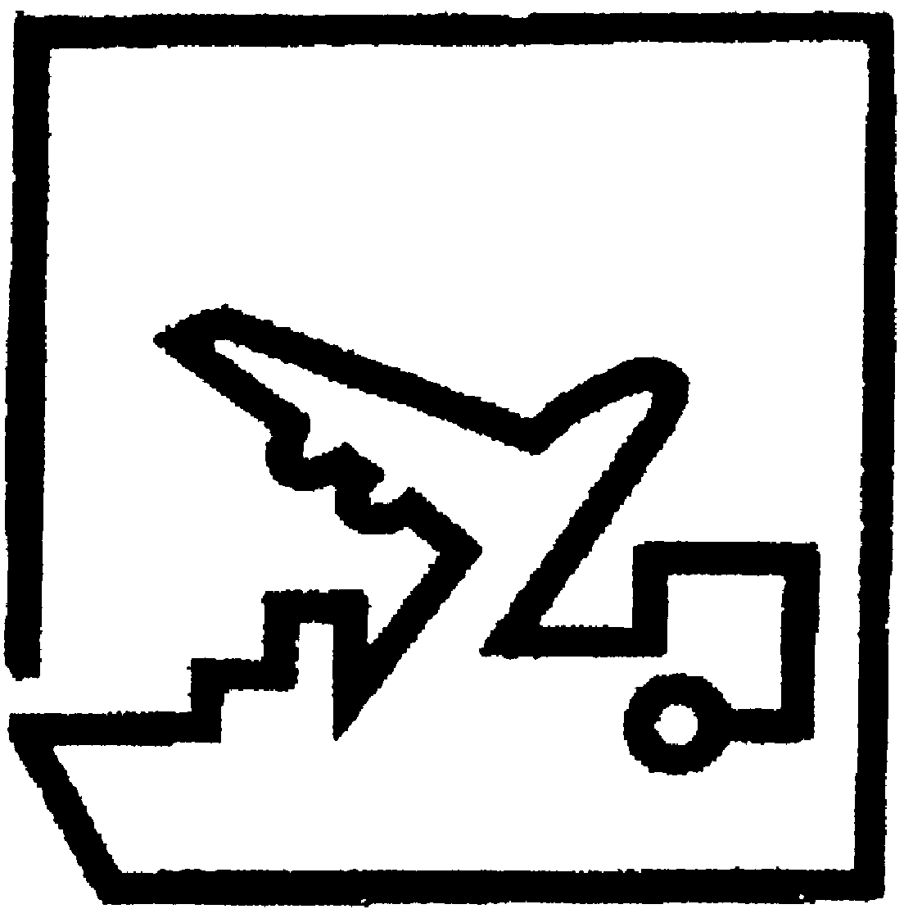

## FREIGHT FORWARDING PRACTICE DIPLOMA

**FINAL EXAMINATION**

**PAPER ONE**

# TRUE OR FALSE/SHORT ANSWER/MULTIPLE CHOICE

**8 APRIL 2021**

**TIME ALLOCATION: (1 HOUR 30 MINS)**

**INSTRUCTIONS**

* Answer ALL questions.
* Remember to write your student number in the space provided on this page and on all other answer sheets you submit.
* Follow the instructions indicated on each section.
* This paper carries 25% of the final examination mark.

**FFP Diploma 2021 Final/P1 Student Number:……………………………**

**SECTION A: True or False:**

**Indicate the correct answer by putting a “T” of “F” in the brackets provided. T denotes TRUE and F denotes FALSE. Answer all questions from this part. Each question carries 1 mark.**

1. Both BIMCO and IMO are specialized agencies of the United Nations. **True/False** Answer ( )
2. A boat or ship engaged in the tramp tradedoes not have a fixed schedule or published ports of call. **True/False** Answer ( )
3. SFAAZ is a member of the Federation of Clearing and Forwarding Associations of Southern Africa (FCFASA). **True/False** Answer ( )
4. A breach on the principle of insurable interest may take the form of material misrepresentation.

**True/False** Answer ( )

1. Packing of goods is storing for future use while packaging is unitisation of packed goods for easy handling. **True/False** Answer ( )
2. Covid-19 is not a business risk in Freight forwarding as cargo continues to be moved.

**True/False** Answer ( )

1. When shipping dangerous goods, Air transport is the least restrictive mode. **True/False** Answer ( )
2. A ‘through rate’ and the box rate are the same thing. **True/False** Answer ( )
3. Container ships are an example of dry cargo vessels  **True/False** Answer ( )
4. Modal combination of land / Sea and inland is more convenient where lead time is a priority.

**True/False** Answer ( )

**FFP Diploma 2021 Final/P1 Student Number:……………………………**

1. The track ballast that is found in rail transportation is the same as the ballast that is used in sea transport. **True/False** Answer ( )
2. Containers have influenced the design of all other modes of transport.

**True/False** Answer ( )

1. In Freight Forwarding business, economies of scale equates with maximising the utilisation of office space, of office equipment and other office assets. **True/False** Answer ( )
2. Installing anti-virus software on the computer is a way of system backup.

**True/False** Answer ( )

1. “Open Marine” policy is most ideal for once off shipments. **True/False** Answer ( )
2. An “Ocean/ Marine” bill of lading is also known as a ‘Through bill of lading. **True/False** Answer ( )
3. The Multimodal Transport Document is also referred to as Combined Document.

**True/False** Answer ( )

1. A Freight Forwarder can perform all functions performed by a clearing agent, but a clearing agent cannot do some of the functions performed by Forwarder. **True/False** Answer ( )
2. Europe has the biggest inland waterways network in the world. **True/False** Answer ( )
3. Insurance is all about the sharing of risk. **True/False** Answer ( )
4. The maximum axle weight on triaxle trailer is 28tons. **True/False** Answer ( )

**FFP Diploma 2021 Final/P1 Student Number:……………………………**

1. An NRZ wagon loaded with ‘bagged’ maize from Beitbridge to Harare is treated as Dry Bulk Shipment.

**True/False** **Answer ( )**

1. Danube River is the longest river in Europe and passes through ten EU countries

**True/False Answer ( )**

1. Durban port is the deepest port in Southern Africa **True/False Answer ( )**
2. Bogie is found in both air and rail modes of transport as it gives buoyance to the modes

**True/False Answer ( )**

1. Road 3, in Zimbabwe links Harare to Bainbridge **True/False Answer ( )**
2. Automated Inventory tracking system is an ICT tool that help in tracking road trucks

**True/False Answer ( )**

1. Lloyd’s of London is an insurance company. **True/False Answer ( )**
2. Movement of abnormal loads is regarded as a project, which in most cases might not recur

**True/False Answer ( )**

1. Suez Canal lies between South America and North America. **True/False** **Answer ( )**

**[TOTAL SECTION A: 30 MARKS]**

**FFP Diploma 2021 Final/P1 Student Number:……………………………**

**SECTION B: Short Answers.**

**Write your answers by in the spaces provided. Marks are indicated at the end of each question.**

1. FIATA acronym stands for? **(1 mark)**

…………………………………………………………………….…….………………………………….

……………………………………………………………………..……………………………………….

1. List 3 risks that the importer/exporter may be exposed to in International Supply Chains. **(3 marks)**
2. ………………………………………………………………………………………………...………
3. ……………………………………………..…………………………….……………………………
4. ……………………………………………………………………………………………...…………
5. List any 3 trading blocs that cover the Africa region. **(3 marks)**
6. …………………………………………………………………………………………………………
7. …………………………………………………………………………………………….……………
8. …………………………………………………………………………………………………….……
9. NVOCC stands for….. **(1 mark)**

…………………………………………………………………………………………………………………………………………………………………………………………………………………………

1. What is a Freight Forwarder? **(1 mark)**

……………………………………………………………………………………………………………...

……………………………………………………………………………………………………………..

…………………………………………………………………………………………….………………..

**FFP Diploma 2021 Final/P1 Student Number:……………………………**

1. List two functions of an Air waybill. **(2 marks)**
2. …………………….……………………………………………………………………………………
3. ………………………………………………………………………………………………………….
4. List 4 ways in which a Freight Forwarder can remain competitive given the fierce business environment they operate in. **(4 marks)**
5. ……………………………………………………………………………...……………………….…
6. ………………………………………………..……………………………………………………..….
7. ……………………………………………………………………………………………….…………
8. ………………………………………………………………………………………………………….
9. List any 3 FIATA Documents that simplify freight logistics **(3 marks)**
10. …………………………………………………………………………………………….….………
11. ………………………………………………………………………………………………..………
12. …………………………………………………………………………………………………………
13. For easier of reference the worlds five continents have been regrouped into three areas. Which continent fall under the following areas? **(3 marks)**

Area 1 …..…………………………………………………………………………..………………………

Area 2 …..…………………………………………………………………………..………………………

Area 3 …..…………………………………………………………………………..………………………

**FFP Diploma 2021 Final/P1 Student Number:……………………………**

1. List the 3 main features of multimodal transport. **(3 marks)**
2. …………………….……………………………………………………………………………………
3. ………………………………………………………………………………………………………….
4. ………………………………………………………………………………………………………….
5. List / Name one disadvantage of Reverse Logistics. **(1 mark)**

…………………………………………………………...………………………………………………………………………………………………………………………………………………………………...

1. What is a Hinterland? **(1 mark)**

……………………………………………………………………………………………………...…………………………………………………………………………..………………………………………….

1. List any 3 types of vessels that ply inland waterways. **(3 marks)**
2. …………………………………………………………………………………………………………
3. ………………………………………………………………….………………………………………
4. …………………………………………………………………………………………………………
5. What is the relevance of the container rating plate to the Freight Forwarder? **(1 mark)**

..............................................................................................................................................................................................................................................................................................................................................

1. What is TT Club? **(1 mark)**

…………………………………………………………………………………………………………………………………………………………………………………………………………………………

**FFP Diploma 2021 Final/P1 Student Number:……………………………**

1. Briefly define the following terms as they apply to rail transport:
2. Rolling stock **(1 mark)**

………………………………………………………………………………………………………………………………………………………………………………………………………………………………………………………………………………………………………………………………………

1. Rail Consignment Note **(1 mark)**

………………………………………………………………………………………………………………………………………………………………………………………………………………………………………………………………………………………………………………………………………

1. Mention any 3 factors that should be considered when tariffing / costing using any mode of transport. **(3 marks)**

………………………………………………………………………………………………………………………………………………………………………………………………………………………………………………………………………………………………………………………………………

1. Which mode of transport is friendly in moving dangerous goods and why? **(2 marks)**

………………………………………………………………………………………………………………………………………………………………………………………………………………………………………………………………………………………………………………………………………

**FFP Diploma 2021 Final/P1 Student Number:……………………………**

1. Identify the dangerous goods label below and state where it is used. **(2 marks)**

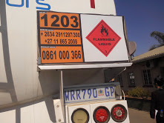

………………………………………………………………………………………………………………………………………………………………………………………………………………………………………………………………………………………………………………………………………………………………………………………….………………………………………………………………………………

**[TOTAL SECTION B: 40 MARKS]**

**FFP Diploma 2021 Final/P1 Student Number:……………………………**

**SECTION C: MULTIPLE CHOICE:**

**Answer all questions in this section. (Each question carries 1 marks) Indicate the correct answer in the brackets provided by putting the correct paragraph number. Do not circle or tick the correct answer.**

1. Which European river has the fall/ rapid used to generate Hydroelectricity?
2. Elbe.
3. Zambezi.
4. Rhine.
5. Thames.
6. Yellow . **Answer ( )**
7. Panama Canal is………………….
8. The canal that links the Atlantic and the Pacific Ocean.
9. The canal that links Mediterranean and Red sea.
10. The canal that links Mediterranean and the Indian Ocean.
11. The canal that links Mediterranean Sea and the Atlantic Ocean.
12. The water channel that links Arctic to Antarctica. **Answer ( )**

1. Which the carrier’s maximum liability is as outlined in the CMR convention of 1956?
2. 17.33 SDR per kg gross weight.
3. 8.33 SDR per kg gross weight.
4. 19.00 SDR per kg gross weight.
5. 8.50 SDR per kg gross weight.
6. 19 SDR per kg gross weight. **Answer ( )**
7. Which INCOTERM has the least costs to the exporter / seller?
8. Ex Works (place).
9. CPT (place).
10. CFR (place).
11. CIP (place).
12. DDP (place). **Answer ( )**

**FFP Diploma 2021 Final/P1 Student Number:……………………………**

1. An LCL container is one which is utilised to carry ............., each of which originates from a different supplier.
2. One Full Container Load from single consignor.
3. One Full Container meant for one Consignee.
4. A number of small consignments.
5. Full loads meant for single importer.
6. None of above. **Answer ( )**
7. A contract of sale that requires the Seller to organize transportation is which of the following?

1. Carrier Haulage.
2. Merchant Haulage.
3. Subcontracts.
4. Cooperatives.
5. None of above . **Answer ( )**
6. One of the strategies recommended to counter new entrants (Porter’s five forces model) is called which of the following?
7. Economy of distance.
8. Economy of scale.
9. Imitation.
10. Ignore.
11. None of above. **Answer ( )**
12. FIATA form denoted by SIC is which of the following?
13. Shippers Declaration for the Transport (Dangerous Goods).
14. Shippers Intermodal weight Certificate.
15. Shippers instructions regarding carriage.
16. Shippers international document.
17. None of above. **Answer ( )**
18. The acronym TACT is which of the following?
19. Tariff Correction Treat.
20. The Air cargo tariff.
21. Tariff accountable convention.
22. The accommodating rate.
23. None of above . **Answer ( )**

**FFP Diploma 2021 Final/P1 Student Number:……………………………**

1. In Air transport, short shipment not resulting from overbooking is called ………………………..?
2. Airfield Black.
3. Bumping.
4. Next Flight Out.
5. Delayed Flight.
6. None of above. **Answer ( )**

1. The acronym WPA as applied in insurance is which of the following?
2. With Particular Average.
3. Without Particular Average.
4. Warehouse Part Average.
5. Worldwide shipper identifications.
6. None of above. **Answer ( )**

1. According to the UN handbook, modes of transport means which of the following?
2. The type of vehicle used for transport.
3. The transport by one mode of transport.
4. The method of transport used for the movement of goods.
5. Any mode apart from pipeline.
6. None of above. **Answer ( )**
7. Which of the following Dangerous Goods Classes is incorrect?
8. Class 6 - Toxic and Infectious Substances
9. Class 7 - Radioactive Material
10. Class 5 - Oxidising and Infectious Substances
11. Class 8 - Corrosives
12. None of the above. **Answer ( )**
13. What is consolidated/ groupage cargo?
14. A large consignment packed in several containers.
15. Non containerized goods carried loose on trucks.
16. Huge machinery disassembled for ease of carriage.
17. Small individual consignments imported in one container.
18. None of the above. **Answer ( )**

**FFP Diploma 2021 Final/P1 Student Number:……………………………**

1. Which UN protocol should be considered (takes priority) when shipping dangerous goods in road/ sea and Air combination?
2. RID.
3. ADR.
4. ADNR.
5. Warsaw.
6. Hamburg rules . **Answer ( )**

1. Soo locks are -
2. Devices that are used at deep sea ports to allow big vessels to load and offload.
3. Devices that are used to regulate water levels in the inland ports in making vessels move in different levels.
4. Devices that are in shallow sea ports to allow small vessels to load and offload.
5. Locks put on entrances to cargo areas in ships.
6. None of the above. **Answer ( )**
7. From the following extract “**4GV/X6/S/08/USA/+AQ2121”** the letters “X6” refer to…
8. Packing Group.
9. Packing Group tested and maximum gross mass (kg).
10. Dangerous Goods Class.
11. Packing Group and Dangerous Goods Class.
12. None of the above. **Answer ( )**
13. Which statement defines Constructive Total Loss?
14. Occurs when the assured’s goods are destroyed/damaged to the extent that they have ceased “to be a thing of the kind”
15. Occurs when goods are reasonably abandoned because their actual loss seems unavoidable or the cost of making good the loss would exceed the insured value of the goods.
16. Occurs when a part of a consignment is lost or damaged but the rest of the consignment arrives safely at its destination.
17. None of above.
18. All of above. **Answer ( )**

**FFP Diploma 2021 Final/P1 Student Number:……………………………**

1. Load securement and stowage plan is very import in international logistics because......
2. The contents of a container are subject to acceleration, deceleration and centrifugal force.
3. In Ocean transport, gravitational forces are rife as the ship/vessel rolls and pitches.
4. Goods should be stowed in such a way that they will not shift their position during transit.
5. All of above.
6. None of above . **Answer ( )**
7. Multi-sectorial (when applied in Multimodal transport) means which of the following?
8. Encompassing the problems and viewpoints of Governments, private industry and public.
9. Ranging from rules, regulations and policies to customer service levels.
10. Both of above.
11. None of above.
12. Does not apply. **Answer ( )**
13. An airline or its agent can quote the charges that are fixed for the LD7 without reference to commodity loaded therein. This is which of the following?
14. Classified rates.
15. Specific commodity rates.
16. ULD charges/ rates.
17. General cargo rates.
18. Deep sea container rate. **Answer ( )**
19. The hire of entire ship from owner for a long period excluding the crew where the Charterer takes possession and control taking good care of vessel is best explained as;
20. Demise charter party.
21. Voyage charter party.
22. Liner services.
23. Rationalised conference.
24. Tramping service. **Answer (**  )

**FFP Diploma 2021 Final/P1 Student Number:……………………………**

1. Which is the ideal rail wagon / rolling for transporting cattle from Beitbridge to Mutare?
2. HIS.
3. DSI.
4. L Truck.
5. Hopper.
6. PNN. **Answer ( )**
7. Rail wagon axle weight is determined by which of the following?
8. Gradient and off course of the cargo.
9. Tare weight of the rolling stock.
10. Size of the rail tracks on the section.
11. What cargo can bear.
12. All of above. **Answer ( )**
13. Which is Zimbabwe National Rails line gauge?
14. 1 067mm.
15. 1 674mm.
16. 1 520mm.
17. 1 000mm.
18. 1 066mm. **Answer ( )**
19. WTO acronym denotes …………………………………….
20. Worldwide Tracking Organisations.
21. World Trade Organisation.
22. World Transport Organisation.
23. World Trade Order.
24. None of the above. **Answer ( )**
25. How do you identify a negotiable Bill of Lading?
26. It is issued with a specific name indicated on consignee.
27. It is usually send, by air, to the consignee as soon as goods are on board ship
28. It is bearing name and ‘order of’ inscription on consignee box
29. It is written / drawn with ‘order of’ on consignee box.
30. None of above. **Answer ( )**

**FFP Diploma 2021 Final/P1 Student Number:……………………………**

1. Sea cargo freight is determined by……..
2. Destination
3. Commodity
4. Box rate
5. CAF and BAF
6. All of above. **Answer ( )**
7. Diversification may take which direction?
8. New service in new market.
9. New service in existing market.
10. Starting new business that is related or not related to what is the norm.
11. Partnerships.
12. All of above. **Answer ( )**
13. How does one make sure She /He is the right recipient of the container?
14. Check the seal and container coding and numbering that it correspond to import documents.
15. Check the operational characteristics of the containers.
16. By opening the container immediately after receipt.
17. Verify the size and type of container against export documents.
18. All of Above. **Answer ( )**

**[TOTAL SECTION C: 30 MARKS]**